**Phase 5**

**Project Title:**Smart Public Restroom

Designing a smart public restroom involves integrating technology and automation to enhance user experience, improve hygiene, and optimize maintenance. Here's a step-by-step procedure to create a smart public restroom:

Creating a smart public restroom involves integrating various technologies to enhance user experience, promote hygiene, and optimize maintenance processes. Here's a step-by-step procedure to design and implement a smart public restroom:

**1. Needs Assessment:**

- Identify the location and expected foot traffic to determine the restroom's size and capacity requirements.

- Conduct surveys or research to understand user preferences and requirements.

**2. Design and Layout:**

- Design an efficient layout for the restroom, considering the placement of fixtures, entry and exit points, and accessibility for people with disabilities.

- Ensure proper ventilation, lighting, and use of eco-friendly materials for sustainability.

**3. Sensor Integration:**

- Implement occupancy sensors to detect when users enter and exit the restroom. This data can be used to manage cleaning schedules and resource utilization.

- Install motion-activated lighting to save energy when the restroom is not in use.

**4. Smart Fixtures:**

- Use smart toilets and urinals with automated flushing mechanisms to promote water conservation.

- Install sensor-based faucets and soap dispensers to encourage hand hygiene and reduce water wastage.

- Integrate smart hand dryers that adjust airflow and duration based on the user's hand movement.

**5. Hygiene Maintenance:**

- Implement a real-time monitoring system to track the restroom's cleanliness status.

- Use sensors to detect toilet paper and soap levels, triggering automatic reordering when supplies are low.

- Integrate self-cleaning technologies, such as UV-C light or antimicrobial coatings, to reduce the need for frequent manual cleaning.

**6. IoT Connectivity:**

- Connect all sensors and smart devices to a centralized Internet of Things (IoT) platform for data analysis and remote monitoring.

- Utilize IoT data analytics to optimize cleaning schedules, water usage, and supply replenishment.

**7. User Experience Enhancement:**

- Provide user-friendly interfaces, such as touchless control panels or mobile apps, to allow users to request assistance or report issues.

- Implement queue management systems to inform users about restroom occupancy and estimated wait times.

**8. Accessibility and Inclusivity:**

- Ensure the restroom is accessible to people with disabilities, incorporating features like wider stalls, grab bars, and low sinks.

- Implement voice-controlled devices or tactile interfaces for users with visual impairments.

**9. Maintenance and Support:**

- Train maintenance staff to handle smart restroom technologies and troubleshoot common issues.

- Establish a proactive maintenance schedule to prevent system failures and ensure a seamless user experience.

- Provide a support system for users to report technical problems or give feedback.

**10. Regular Updates and Feedback:**

- Collect feedback from users to identify areas for improvement and gauge user satisfaction.

- Stay updated with emerging technologies and trends to continuously enhance the smart restroom features.

By following these steps and staying mindful of user needs and technological advancements, you can create an efficient, user-friendly, and sustainable smart public restroom.

**Project description:**

A smart toilet, by definition, uses integrated technology and data to interact and connect with the user. It's designed to improve the hygiene level and personal cleansing experience. Moreover, it gives insight to stakeholders to save manpower & resources, and enhances safety, operations and customer experience.

The concept of modern smart toilets [**originated in Japan in the 1980s**](https://www.lifewire.com/what-is-a-smart-toilet-4628135)**.** Kohler released the world's first smart toilet named Numi in 2011, which allows users to set their ambient lighting, adjust the water temperature, and enjoy music with the built-in radio. Now, as technology marches forward, smart toilets have been hailed as the next big thing with more advanced functions and features.

These new modern toilets are part of China's efforts to implement AI into daily life and come hot on the heels of [smart bins](https://www.guardforce.com.hk/en/security-technologies/smart-bin) and AI-powered traffic lights.

There are many high-tech public toilets in Hong Kong tourist spots to overhaul conditions in the city's public conveniences. [Shanghai has also built around 150 smart public restrooms](https://www.scmp.com/tech/innovation/article/3033187/reading-book-shanghai-toilet-could-be-bad-idea-if-you-dont-want-be)to improve their tarnished image.

A smart toilet system is also a saviour for the organizations where they have to manage multiple toilets - it reduces manpower and keeps restrooms cleaner. The system can also assist cleaning companies in managing their staff and timetables effectively.

**IoT implementation:**

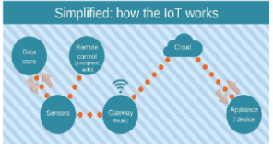

Sound sensor or mic sensor provides digital output and it detects sound from atmosphere. A WiFi module is also connected to Arduino and it is used to transfer data from the sensors to cloud server. ESP8266 WiFi module is used to store the data to online server. The data from sensor are basically analog signal so analog to digital converter (ADC) is used to convert the data. 16 x 2 Liquid crystal display (LCD) is used to display the measured value from the sensors. It can display two lines and each line has 16 characters.

**Methodology:**

The MQ-135 sensor detects the stench of the toilet. The presence of ammonia gas in the atmosphere is detected by this sensor. The presence of Ammonia is responsible for the toilet's foul odour. Ammonia has a pungent odour that can only be perceived at a concentration of 5 parts per million (parts per million).Fans automatically turn on when the ammonia content in the toilet exceeds the set threshold of 5 ppm, while levels below 5 ppm have no impact. Moving on to the next component, an infrared sensor is used to check for the presence of soap in the toilet.

**Block diagram:**

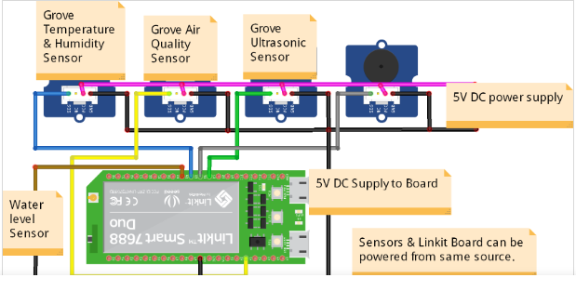

**Schematic :**

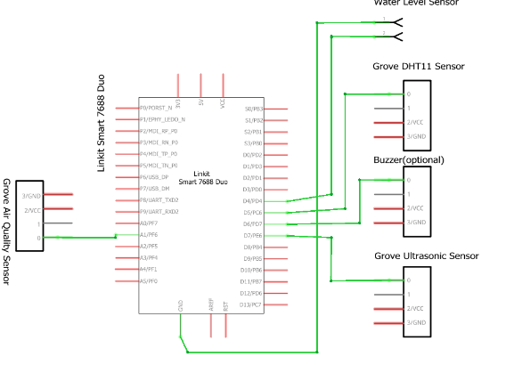

**App Development :**

As the app was created by using Visual Studio Code, the app will display the data takenfrom the sound sensor. Visual Studio Code is a software to create app use Python language todesign an Android development .Smart public toilet product solutions can monitor the temperature, humidity, odor and other environmental parameters in the public toilet through environmental monitoring sensors, and automatically adjust the temperature, humidity and ventilation system in the public toilet according to the parameters to improve comfort and hygiene.

**Benefits of using smart toilet:**

Improved Customer Satisfaction.

Optimized Cleaning for washroom.

Energy Saving with Optimized Heating and Air Conditioning.

Cost Saving in Inventory, Delivery, and Logistics.

**Conclusion:**

A rapid change of delivery and more rigid, developing conditions don’t need to lag your operations. With Faststream Technologies’s Smart Restroom solution, we’ll provide you with everything you need to digitize your [bathroom](https://www.faststreamtech.com/solutions/connected-smart-home-appliances/smart-bathroom-solutions/) and toilet operations and get the most out of your cleaning supplies, staff, and customer satisfaction.

We offer an integrated Smart Toilet Management system connected with the sensors, gateways, networks, and the cloud to get your data flowing into the software dashboard or platform. Our Smart Restroom systems will give data space usage or consumption of paper, hand wash, and soap in your washrooms along with smart toilet people counter.

Faststream’s smart restroom solution is ideal for client places such as large airports, shopping malls, stadiums, hospitals, and schools where large footfalls are common as it is able to identify any hygiene or operational issues, leaks or breakdowns, and send SMS alerts so your team can address the problem.

**App coding :**

**\\markdown**

smart_restroom_app/

|- templates/

|- index.html

|- app.py

**\\html**

<!DOCTYPE html>

<html lang="en">

<head>

<meta charset="UTF-8">

<meta name="viewport" content="width=device-width, initial-scale=1.0">

<title>Smart Restroom App</title>

<link rel="stylesheet" href="https://maxcdn.bootstrapcdn.com/bootstrap/4.0.0/css/bootstrap.min.css">

</head>

<body>

<div class="container mt-5">

<h1>Smart Public Restroom</h1>

<p>Status: {{ status }}</p>

<button id="occupancyButton" class="btn btn-primary">Toggle Occupancy</button>

<br><br>

<textarea id="feedback" class="form-control" placeholder="Provide feedback"></textarea>

<button id="feedbackButton" class="btn btn-success mt-2">Submit Feedback</button>

</div>

<script>

document.getElementById('occupancyButton').addEventListener('click', function() {

// Implement code to toggle occupancy status via AJAX request

});

document.getElementById('feedbackButton').addEventListener('click', function() {

var feedbackText = document.getElementById('feedback').value;

// Implement code to send feedback via AJAX request

});

</script>

</body>

</html>

To create a platform displaying real-time restroom availability and cleanliness data using web development technologies,

1**. Frontend Development:**

HTML:

Create the structure of your web page. For example:

#Program

<!DOCTYPE html>

<html lang="en">

<head>

<meta charset="UTF-8">

<meta name="viewport" content="width=device-width, initial-scale=1.0">

<title>Restroom Availability</title>

<link rel="stylesheet" href="styles.css">

</head>

<body>

<div class="restroom-container" id="restroom-container">

<!-- Restroom data will be dynamically inserted here -->

</div>

<script src="script.js"></script>

</body>

</html>

CSS (styles.css):

Style your web page for a better user experience. For example:

#Program

body {

font-family: Arial, sans-serif;

background-color: #f2f2f2;

margin: 0;

padding: 0;

.restroom-card {

background-color: white;

border-radius: 10px;

box-shadow: 0 4px 8px 0 rgba(0, 0, 0, 0.2);

margin: 20px;

padding: 20px;

}

.restroom-card h2 {

margin-bottom: 10px;

}

.restroom-card p {

margin: 0;

}

**JavaScript (script.js):**

Use JavaScript to fetch real-time data from the server and update the HTML dynamically. You can use AJAX, Fetch API, or libraries like Axios for making API requests. For example, using Fetch API:

#Program

const restroomContainer = document.getElementById("restroom-container");

function fetchRestroomData() {

fetch("/api/restrooms") // Assuming your API endpoint is /api/restrooms

.then(response => response.json())

.then(data => {

// Clear previous data

restroomContainer.innerHTML = "";

// Iterate through restroom data and create cards

data.forEach(restroom => {

const card = document.createElement("div");

card.classList.add("restroom-card");

card.innerHTML = `

<h2>${restroom.name}</h2>

<p>Availability: ${restroom.availability}</p>

<p>Cleanliness: ${restroom.cleanliness}</p>

`;

restroomContainer.appendChild(card);

});

})

.catch(error => {

console.error("Error fetching restroom data:", error);

});

}

// Fetch data initially and set interval for periodic updates

fetchRestroomData();

setInterval(fetchRestroomData, 5000); // Update every 5 seconds (adjust as needed)

2. **Backend Development:**

You would need a backend server to handle API requests and provide real-time data. Here's a simple example using Node.js and Express.js:

#Program

const express = require("express");

const app = express();

// Sample restroom data (replace this with data from your database)

const restrooms = [

{ id: 1, name: "Restroom 1", availability: "Available", cleanliness: "Clean" },

{ id: 2, name: "Restroom 2", availability: "Occupied", cleanliness: "Slightly Dirty" },

];

app.use(express.json());

// API endpoint to get restroom data

app.get("/api/restrooms", (req, res) => {

res.json(restrooms);

});

const PORT = 3000;

app.listen(PORT, () => {

console.log(`Server is running on port ${PORT}`);

});

In this example, the server provides restroom data when a GET request is made to the /api/restrooms endpoint.

3. **Testing and Deployment:**

**Testing:** Test your web application to ensure that real-time data updates are displayed correctly. Handle potential errors gracefully.

**Deployment:** Deploy your backend server and frontend files on a hosting platform (such as Heroku, Netlify, or Vercel) to make your platform publicly accessible.

By following these steps, you can create a platform that displays real-time restroom availability and cleanliness data using web development technologies. Make sure to customize the code and styles according to your specific requirements and integrate a suitable backend system for fetching real-time data.

**Mobile App Design:**

**User Interface (UI) Design:**

**Clean and Intuitive UI:** Design a user-friendly interface with easy navigation and intuitive controls.

**Real-time Updates :** Implement real-time data updates for restroom availability and cleanliness.

**Maps Integration:** Integrate Google Maps or any other mapping service to display restroom locations.

Feedback System: Include a feedback feature allowing users to rate and provide feedback on restroom cleanliness.

Functionality:

Real-time Data: Fetch real-time restroom data from the server using APIs.

Maps Integration: Display restroom locations on the map with markers for easy navigation.

Search Functionality: Implement a search feature allowing users to find nearby restrooms.

Filters: Provide filters based on cleanliness, availability, accessibility, etc.

User Reviews: Show user reviews and ratings for each restroom.

Push Notifications: Optionally, send push notifications for restroom availability updates or new nearby restrooms.

Technical Implementation:

iOS App (Swift):

Use Swift programming language for iOS app development.

Utilize Xcode IDE for development.

Implement real-time functionality using WebSockets or Push Notifications.

Integrate Google Maps SDK for iOS for mapping functionality.

Android App (Java/Kotlin):

Use Java or Kotlin programming language for Android app development.

Utilize Android Studio IDE for development.

Implement real-time functionality using WebSockets or Push Notifications.

Integrate Google Maps SDK for Android